1] Number of subarrays whose sum <= K (All numbers in the array>=0)

Template for problems:- [i………………………..j] < = k

Number of subarrays whose sum <= K
(All numbers in the array>=0)

-> [2 1 1 5 8]
K = 4

There are 6 subarrays whose sum<=K :- [0…0] , [0….1] , [0….2] ,[1…1],[2..2],[1….2]

Brute Force:-

Py https://ideone.com/Ri10mA.

TC - O(N^2)
SC - O(1)

Efficient:-

Py https://ideone.com/k9299d.

Number of subarrays whose count of distinct number <= K

Brute Force:-
Py https://ideone.com/9vjhZm.

Efficient :-
Py https://ideone.com/r6qAbV

Number of pairs whose absolute diff <=K

Brute Force:-

Py https://ideone.com/IKYGmh.

Efficient :-
Py https://ideone.com/7nTVEt

Practice Question 1 :- Find count of subarrays whose sum>=k
Way 1 :- Total number of subarrays {n*(n+1)/2} - (count of subarrays whose sum<=k-1)

Way 2 :- https://ideone.com/1EafpT

Practice Question 2 :-

Prerequisite:- Watch session 1 of “Sorted Set” course from 851 hour hard level DSA + OA + CP course doc -> go to 851 hour course doc -> do CTRL + F “Sorted Set” and go through it

Once done go through ->

First do this - https://leetcode.com/problems/longest-continuous-subarray-with-absolute-diff-less-than-or-equal-to-limit/

On the same concept next question :-

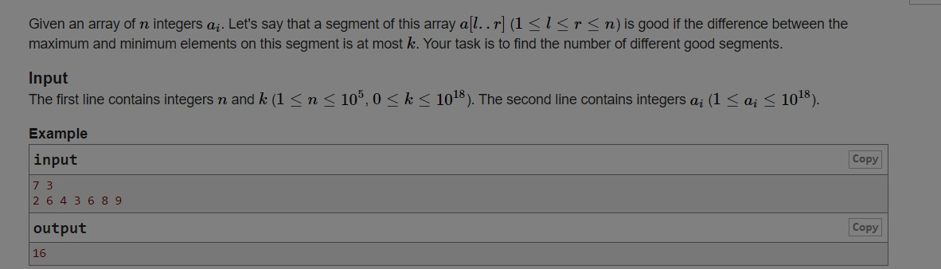

2a] largest subarray whose sum is less than k

2b] largest valid substring, where any pair of chars have diff<=k

3] Two players are playing a game with a sequence of n integers.
- Player 1 starts first, and the players alternate turns.
- On each turn, the current player removes the first element of the sequence and adds its value to their score.
- If the removed element is even, the remaining sequence is reversed before the next player's turn.
- The game continues until all elements have been removed.
Find the absolute difference between the final scores of Player 1 and Player 2.
Input:
An integer n representing the number of elements, followed by a sequence of n integers.
Output:
Return the absolute difference between Player 1's score and Player 2's score.

def score_difference(arr):
start = 0
end = len(arr) - 1

p1 = 0
p2 = 0

turn = 1
reversed_flag = False

while start <= end:
# Remove "first element" based on current orientation
if not reversed_flag:
selected = arr[start]
start += 1
else:
selected = arr[end]
end -= 1

# Add selected value to current player's score
if turn % 2 == 1:
p1 += selected
else:
p2 += selected

# Reverse remaining sequence if selected element is even
if selected % 2 == 0:
reversed_flag = not reversed_flag

turn += 1

return abs(p1 - p2)

# Example usage
n = int(input())
arr = list(map(int, input().split()))

print(score_difference(arr))

4] Given a sorted array of size N; find the number of quadruplets (i,j,k,l) such that -> a[i] + a[j] > k1 && a[k] + a[l] > k2

-> Will i < j < k < l -> Yes;

-> What is the nature of numbers in the array -> Both positive / negative ;

-> Bound on array elements and k1,k2 -> abs(a[i],k1,k2)<=100000000;

Input -> [1,1,1,1,2,2] k1=1 k2 = 3;
-> 6 [1,2,5,6],[2,3,5,6],[3,4,5,6],[1,4,5,6],[1,3,5,6],[2,4,5,6];

Brute Force :-> Run 4 nested for loops;

C++ - https://www.jdoodle.com/ia/1Igr
Java -
Py -

TC -> O(N^4;);

-> Takes O(1) size space;

Optimization :-> Easy version;

-> Given a sorted array of size N; find the count(number) of pairs (i,j) such that a[i] + a[j] > k -> (i<j)

-> Brute Force :- O(N^2) ;

Optimization :-> Two pointers;

-> i==1 and j==N; if(a[1] + a[N]>k) -> (1,N) is a good pair

-> it means all the pairs -> (1,N) , (2,N) , (3,N) ,.......(N-1,N) -> all are valid;

-> c = c + j-i

-> for the given j==N; we have found the smallest “i” such that a[i]+a[j]>k -> j=j-1;
-> (1,N-1) -> if a[1] + a[N-1] > k -> (1,N-1),(2,N-1),........(N-2,N-1)

-> c = c + j-i

-> j = j-1;

-> (1,N-2) -> if a[1] + a[N-2] <=k -> for j==N-2; i==1 is not the smallest index which can give pair sum > k -> so now do i++

-> (2,N-2) -> if (a[2]+a[N-2]) > k → repeat same algorithm;

Logic -> https://www.jdoodle.com/ia/1IeY

TC - O(N);

-> Takes O(1) sz; space;

Real version :-> Count quadruplets for each “j”;

-> f(j=2;--->N-2){ -> O(N)

-> single loop i from 1 to j-1 to find all valid (i,j) such that -> a[i] + a[j] > k1

-> single loop where k == j + 1 and l == N; -> run the O(N) algorithm to find all valid (k,l) such that a[k] + a[l] > k2;

}

TC :-> O(2*N^2) == O(N^2);

-> Takes O(1) size space;

Py - https://www.jdoodle.com/ia/1Igy

n=int(input())
k1,k2=map(int,input().split())
a=[0]+list(map(int,input().split()))
c=0
for j in range(2,n):
i=j-1
c1=0
while i>=1:
if a[i]+a[j]>k1:
c1+=1
i-=1
c2=0
k=j+1
l=n
while k<l:
if a[k]+a[l]>k2:
c2+=l-k
l-=1
else:
k+=1
c+=c1*c2
print(c)

Optimization :->

Binary search on “i” for left count -> O(logN)

-> a[i] + a[j] > k1

-> a[i] > k1 - a[j]

-> binary search on the sorted array in the range [1…..j-1] -> find the smallest “i” such that a[i] > k1-a[j]

-> left_count = (j-i) -> O(logN)

-> right_count = O(1)

How do you precalculate right_count to access its answer in O(1)

-> s[k] ⇒ all valid pairs (k,l) such that k<l and they are in the range [k…..N];

-> s[k] => all valid pairs (k,l) for a fixed “k” and all the pairs are in the range [k….N];

-> s[n] -> O(logN)

-> s[n-1] -> O(logN)
.
.
.
.
.
-> s[1] -> similarly

-> suffix[k] ⇒ s[k] + s[k+1] + s[k+2] + ……………. + s[n];

-> suffix[i] = s[i] + suffix[i+1]

TC -> O(NlogN);

-> Takes O(N) size space;

—------------------------------------------------------------------------

Final Optimization :-> O(N;);

-> left_count => you need to know valid pairs (i,j) -> such that j is fixed when calculating p[j] for each “j” and then summing up ; and “i” is in the range [1……j-1];

-> p[j] ⇒ all valid pairs (i,j) such that “j” is fixed; i is in the range [1….j-1]
-> pre-calculation of p array in O(N) done;
-> left_count => p[j]; -> O(1)

-> right_count => s[k] =>

i=1,j=2;

-> if(a[i]+a[j]>k2){ -> s[i] = abs(j-N+1); //RRRRR
i++;
} else {
j++;
}

C++ -
Java -
Py -

